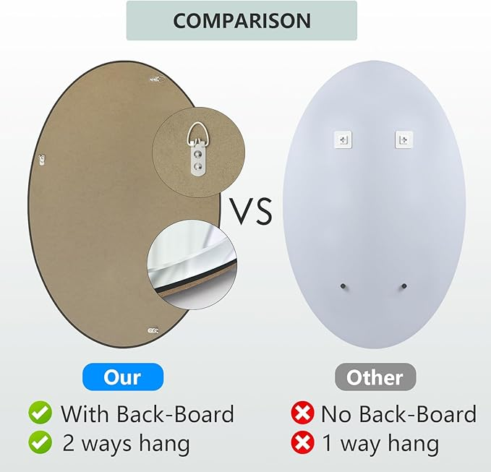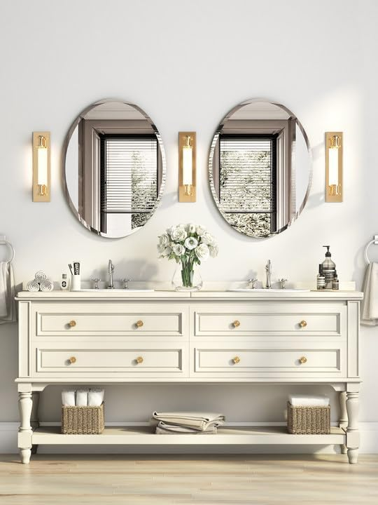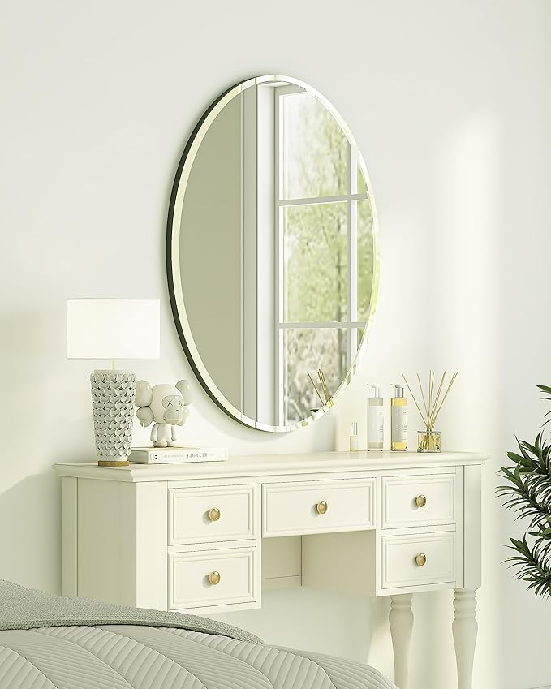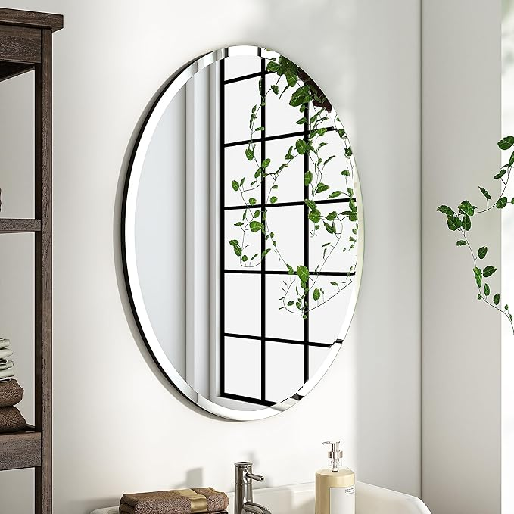

KOHROS Bathroom Mirrors for Over Sink - Oval Frameless Mirror - Beveled Polished Wall Mirror for Bathroom, Vanity, Bedroom (18" W x 24" H Oval)

**PRODUCT DESCRIPTION:**

|  |  |
| --- | --- |
| Brand | KOHROS |
| Room Type | Bathroom |
| Shape | Oval |
| Product Dimensions | 17.7"L x 23.6"W |
| Frame Material | Glass |

**About this item**

* EYE-CATCHING DESIGN Classic, frameless, beveled edges, oval design make this bathroom mirror so eye-catching. Sleek oval mirror is a not only oval bathroom mirror, also be an adornment, making a personalized statement over any bathroom vanity, powder room or on any wall in your home
* PERFET TOUCH The smooth edges of living room mirror are hand polished to ensure safety and beauty. As a reflective surface, give room a better sense of light and space. The decor wall mirror can be hung horizontally and vertically, either way the bathroom mirrors for over sink will create a wonderful illusion of increased space
* HD IMAGING All mirror use high-end 4mm thick silver glass mirror, which provides a clear distortion-free reflection, and eliminate the common reflective distortion of low-end mirrors. The oval vanity mirror has a clear image and can bring you the best visual experience
* OCCASION This frameless bathroom mirror gives a perfect look, is easy to hang and control, oval bathroom mirror ,supports both horizontal and vertical hanging. It is also the perfect beveled mirror for the living room, dining room,bedroom, entrance,hallway,and other walls
* AFTER-SALES SERVICE Your satisfaction is our top priority. If you have any questions about your new mirror, please feel free to email us. We have a professional after-sales team to solve your problems. Yours sincerely,KOHROS